**Supplementary Information**

*Table S1. Summary table for meta-analysis conclusion [1], [2], [3], [4], [5], [6], [7], [8], [9], [10], [11], [12], [13], [14], [15], [16], [17], [18], [19], [20].*

|  |  |  |  |  |  |
| --- | --- | --- | --- | --- | --- |
| Number of Studies | Impact on Soil productivity | Impact on Soil Microbial Biomass | Impact on Soil Nutrients | Impact on Soil pH | Reference Number |
| 23 | Positive |  |  |  | 11 |
| 371 | Positive | Positive | C: Positive N: Positive P: Positive |  | 14 |
| 103 | Positive | Positive |  | Positive | 8 |
| 111 | Positive |  |  |  | 16 |
| 50 | Neutral | Positive | C: Positive |  | 1 |
| 40 | Positive |  |  | Positive | 4 |
| 136 | Positive |  |  |  | 12 |
| 56 | Positive |  |  | Positive | 17 |
| 17 | Positive |  |  |  | 6 |
| 72 | Hazardous | Positive |  | Positive | 13 |
| 49 | Hazardous | Positive |  |  | 3 |
| 153 | Positive |  | C: Positive |  | 2 |
| 59 | Positive | Positive | C: Positive | Positive | 10 |
| 194 | Neutral | Positive | C: Positive |  | 7 |
| 143 | Positive |  | C: Positive | Positive | 18 |
| 57 | Positive |  |  |  | 9 |
| 62 | Positive |  |  | Positive | 5 |
| 74 | Positive |  |  |  | 19 |
| 242 | Positive |  |  |  | 15 |
| 21 | Positive | Positive |  |  | 20 |

*Table S2 Details about subgroups in meta-analysis*

|  |  |  |
| --- | --- | --- |
| **Grouping** |  | **Number of Data Points** |
| Test Organisms | Animal/Bacteria  Plant | 481 821 |
| pH of biochar | < 6 6-8  ≥ 8 | 76 250 905 |
| Pyrolysis Temperature | < 550 ℃  ≥ 550 ℃ | 710 611 |
| Application rate | < 50 g/Kg  50 g/Kg – 100 g/Kg  ≥ 100 g/Kg | 971 250 176 |
| Biochar Type | Plant Waste Sludge Mix | 923 140 127 139 |
| Endpoint Type | Growth Reproduction Survival | 618 572 139 |
| Soil pH | < 5  5 – 6  ≥ 6 | 88 14 706 |

*Figure S1. Comprehensive relationship between descriptors. Abbreviations: Electrical Conductivity (EC), Organic Carbon (OC),*

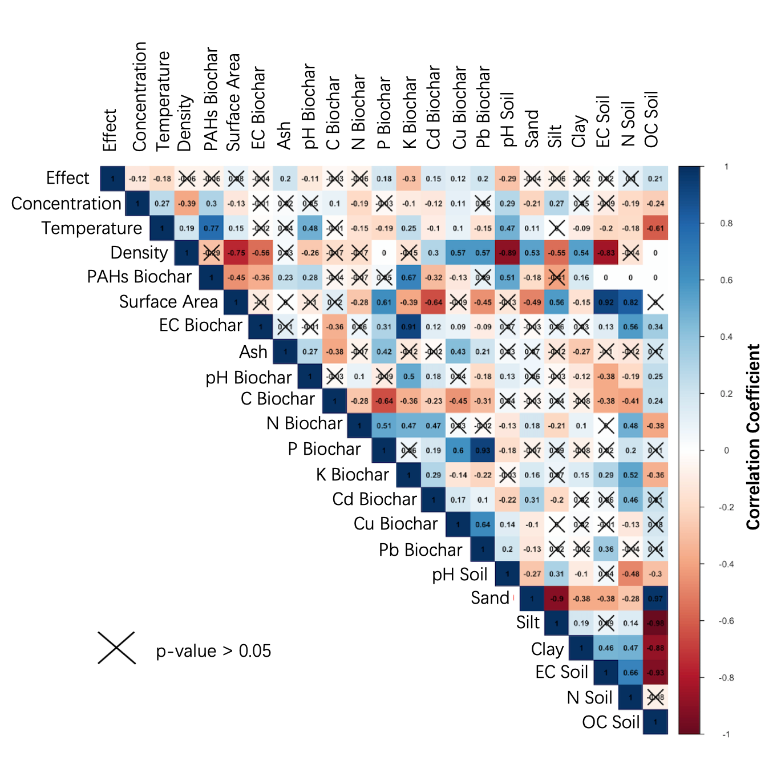

*Table S3. Details of descriptors pre-processing for machine learning*

|  |  |  |  |  |
| --- | --- | --- | --- | --- |
| Descriptors | Treatment | Detail | Unit | Missing Value Treatment |
| Endpoint type (growth) | One hot coding | Growth (1), not growth (0) |  |  |
| Endpoint type (survival) | One hot coding | Survival (1), not survival (0) |  |  |
| Endpoint type (reproduction) | One hot coding | Reproduction (1), not reproduction (0) |  |  |
| Tested organisms (animal/bacteria or plant) | One hot coding | Animal/bacteria (1), plant (0) |  |  |
| Biochar type (Plant) | One hot coding | Plant (1), not plant (0) |  |  |
| Biochar type (waste) | One hot coding | Waste (1), not waste (0) |  |  |
| Biochar type (sludge) | One hot coding | Sludge (1), not sludge (0) |  |  |
| Biochar type (mix) | One hot coding | Mix (1), not mix (0) |  |  |
| Application rate | Normalization | Numeric | % (w/w) | Median |
| Pyrolysis temperature | Normalization | Numeric |  | Median |
| Biochar pH | Normalization | Numeric | °C | Median |
| Biochar C content | Normalization | Numeric | % | Median |
| Biochar N content | Normalization | Numeric | mg/Kg | Median |
| Biochar Cd content | Normalization | Numeric | mg/Kg | Median |
| Biochar Cu content | Normalization | Numeric | mg/Kg | Median |
| Biochar Pb content | Normalization | Numeric | mg/Kg | Median |
| Biochar PAHs content | Normalization | Numeric | mg/Kg | Median |
| Biochar electrical conductivity | Normalization | Numeric | S | Median |
| Soil pH | Normalization | Numeric |  | Median |
| Soil texture (sandy) | Normalization | Numeric | % | Median |
| Soil texture (silt) | Normalization | Numeric | % | Median |
| Soil texture (clay) | Normalization | Numeric | % | Median |
| Soil organic content | Normalization | Numeric | % | Median |

*Table S4. Performance of ternary classification model. Bacc here in the model means binary accuracy, which means the accuracy for ternary models to categorize “beneficial” and “hazardous”. For ternary classification model, each category has a sensitivity, means the percentage of correct identification in this category.*

|  |  |  |  |  |  |
| --- | --- | --- | --- | --- | --- |
| Ternary Classification Models | | SVM linear | SVM Gaussian | NN | RF |
| Testset | Accuracy | 0.51 | 0.58 | 0.61 | 0.64 |
| 95% CI | 0.45 - 0.57 | 0.53 - 0.64 | 0.56 - 0.67 | 0.59 - 0.70 |
| Bacc | 0.66 | 0.75 | 0.79 | 0.80 |
| Sensitivity (Beneficial) | 0.45 | 0.5 | 0.53 | 0.62 |
| Sensitivity (Hazardous) | 0.60 | 0.77 | 0.65 | 0.71 |
| Sensitivity (Neutral) | 0.47 | 0.42 | 0.65 | 0.58 |
| Kappa | 0.26 | 0.36 | 0.42 | 0.46 |
| Training Set | Accuracy | 0.51 | 0.63 | 0.74 | 0.81 |
| 95% CI | 0.48 - 0.55 | 0.60 - 0.66 | 0.71 - 0.77 | 0.78 - 0.83 |
| Bacc | 0.70 | 0.81 | 0.89 | 0.90 |
| Sensitivity (Beneficial) | 0.56 | 0.64 | 0.65 | 0.81 |
| Sensitivity (Hazardous) | 0.6 | 0.78 | 0.81 | 0.87 |
| Sensitivity (Neutral) | 0.36 | 0.41 | 0.71 | 0.70 |
| Kappa | 0.26 | 0.43 | 0.60 | 0.70 |

*Table S5. Exclusion criteria for selecting paper*

|  |
| --- |
| **Exclusion criteria** |
| Research of biochar effects on endpoints other than survival, growth and reproduction |
| Research on materials with name "hydrochar" or "charcoal" without mentioning biochar |
| Research of biochar effect in aquatic environment |
| Research with test conducted in contaminated soil |
| Research without specifying the target species (for example, test about the effect on microbiome community) |
| Research with test conducted with spiked soil (added with fertilizer or amelioments such as compost or sludge) |
| No report of the statistical significance of the findings, making the extraction of the effect impossible |

*Table S6. Details of recorded descriptors in the dataset*

|  |  |
| --- | --- |
| Descriptor Type | Name |
| Biochar Properties (16) | Pyrolysis temperature (℃), Application rate (g/Kg), Ash Content (%), Electronic conductivity (EC, S/cm), Specific surface area (%), Density (Kg/m3), Biochar pH, Carbon content (%), Nitrogen content (%), Phosphorus content (%), Potassium content (%), Cd (mg/Kg), Cu (mg/Kg), Pb (mg/Kg), PAHs content (mg/Kg), biochar type (plant, waste, sludge and mix) |
| Soil Properties (6) | Soil type, Soil texture (percent of sandy, silt, clay), Soil pH, EC (miuS/cm), Nitrogen content (%), organic matter content (%), |
|  |
| Endpoint Type (1) | Name (Growth, Reproduction, Survival) |  |
| Tested Organisms (2) | Name of species, Type of species (Animal/bacteria, Plant) |  |
| Toxicity Test Value (2) | Effect, Standard deviation of Effect |  |

Table S7. Parameter settings of the model in the code

|  |  |
| --- | --- |
| **Name** | **Parameter Settings** |
| Random Forest | After parameters optimization of the model, the parameter set was as follows: ‘ntrees’ = 3000, ‘nodesize’ = 11, ‘mtry’ = 2. |
| Neural Network | Because the dataset has 23 descriptors, the number of nodes in the input layer is 23, and the number of nodes in the hidden layer was set to 12. The number of hidden layers was 1. |
| Supporting Vector Machine | two different SVM models were used for the binary classification of biochar. The first one used a linear SVM, where the parameter ‘Kernel’ of the svm function was set equal to “linear” in the ’e1071’ package, and the second one was a Gaussian SVM, where the parameter ‘Kernel’ parameter was set to “radial”. |

Figure S2. Explanation about sensitivity, specificity, and kappa. Sensitivity: addressing models’ ability of categorizing positive value. Specificity: addressing models’ ability of categorizing positive value. Kappa: compared how model performed to random guessing, usually > 0.4 can be considered performed well.

**Reference**

[1] S. Jeffery, F. G. A. Verheijen, M. van der Velde, and A. C. Bastos, “A quantitative review of the effects of biochar application to soils on crop productivity using meta-analysis,” *Agric Ecosyst Environ*, vol. 144, no. 1, pp. 175–187, 2011.

[2] L. A. Biederman and W. S. Harpole, “Biochar and its effects on plant productivity and nutrient cycling: a meta‐analysis,” *GCB bioenergy*, vol. 5, no. 2, pp. 202–214, 2013.

[3] X. Liu *et al.*, “Biochar’s effect on crop productivity and the dependence on experimental conditions—a meta-analysis of literature data,” *Plant Soil*, vol. 373, pp. 583–594, 2013.

[4] S. Jeffery *et al.*, “Biochar boosts tropical but not temperate crop yields,” *Environmental Research Letters*, vol. 12, no. 5, p. 053001, 2017.

[5] S. Liu *et al.*, “Response of soil carbon dioxide fluxes, soil organic carbon and microbial biomass carbon to biochar amendment: a meta‐analysis,” *Gcb Bioenergy*, vol. 8, no. 2, pp. 392–406, 2016.

[6] A. Crane-Droesch, S. Abiven, S. Jeffery, and M. S. Torn, “Heterogeneous global crop yield response to biochar: a meta-regression analysis,” *Environmental Research Letters*, vol. 8, no. 4, p. 044049, 2013.

[7] Y. Xiang, Q. Deng, H. Duan, and Y. Guo, “Effects of biochar application on root traits: a meta‐analysis,” *GCB bioenergy*, vol. 9, no. 10, pp. 1563–1572, 2017.

[8] L. Ye, M. Camps‐Arbestain, Q. Shen, J. Lehmann, B. Singh, and M. Sabir, “Biochar effects on crop yields with and without fertilizer: A meta‐analysis of field studies using separate controls,” *Soil Use Manag*, vol. 36, no. 1, pp. 2–18, 2020.

[9] S. C. Thomas and N. Gale, “Biochar and forest restoration: a review and meta-analysis of tree growth responses,” *New For (Dordr)*, vol. 46, no. 5–6, pp. 931–946, 2015.

[10] P. Pokharel, Z. Ma, and S. X. Chang, “Biochar increases soil microbial biomass with changes in extra-and intracellular enzyme activities: a global meta-analysis,” *Biochar*, vol. 2, pp. 65–79, 2020.

[11] L. Zhang, Y. Jing, Y. Xiang, R. Zhang, and H. Lu, “Responses of soil microbial community structure changes and activities to biochar addition: a meta-analysis,” *Science of the Total Environment*, vol. 643, pp. 926–935, 2018.

[12] Y. Dai, H. Zheng, Z. Jiang, and B. Xing, “Combined effects of biochar properties and soil conditions on plant growth: A meta-analysis,” *Science of the total environment*, vol. 713, p. 136635, 2020.

[13] H. Singh, B. K. Northup, C. W. Rice, and P. V. V. Prasad, “Biochar applications influence soil physical and chemical properties, microbial diversity, and crop productivity: a meta-analysis,” *Biochar*, vol. 4, no. 1, p. 8, 2022.

[14] X. Li, T. Wang, S. X. Chang, X. Jiang, and Y. Song, “Biochar increases soil microbial biomass but has variable effects on microbial diversity: A meta-analysis,” *Science of the Total Environment*, vol. 749, p. 141593, 2020.

[15] H. Xu *et al.*, “Effects of biochar application on crop productivity, soil carbon sequestration, and global warming potential controlled by biochar C: N ratio and soil pH: A global meta-analysis,” *Soil Tillage Res*, vol. 213, p. 105125, 2021.

[16] Y. Gao, G. Shao, J. Lu, K. Zhang, S. Wu, and Z. Wang, “Effects of biochar application on crop water use efficiency depend on experimental conditions: A meta-analysis,” *Field Crops Res*, vol. 249, p. 107763, 2020.

[17] S. Farhangi-Abriz, S. Torabian, R. Qin, C. Noulas, Y. Lu, and S. Gao, “Biochar effects on yield of cereal and legume crops using meta-analysis,” *Science of the Total Environment*, vol. 775, p. 145869, 2021.

[18] Y. Liu *et al.*, “A quantitative review of the effects of biochar application on rice yield and nitrogen use efficiency in paddy fields: A meta-analysis,” *Science of the Total Environment*, vol. 830, p. 154792, 2022.

[19] Y. Gao *et al.*, “Influences of soil and biochar properties and amount of biochar and fertilizer on the performance of biochar in improving plant photosynthetic rate: A meta-analysis,” *European Journal of Agronomy*, vol. 130, p. 126345, 2021.

[20] E. Mak-Mensah, P. B. Obour, E. Essel, Q. Wang, and J. K. Ahiakpa, “Influence of plastic film mulch with biochar application on crop yield, evapotranspiration, and water use efficiency in northern China: a meta-analysis,” *PeerJ*, vol. 9, p. e10967, 2021.